School of Informatics & IT

Diploma in Cybersecurity and Digital Forensics

CDF3C01 – Incident Response and Management (ICRM)

Lab 2 – Security Incident Response Policy and Plan II

Learning Outcomes
By the end of this practical lesson, the student should be able to demonstrate the following items:
- Recognise the various security incident models and its differences.
- Apply the security incident model to depict the structure of an incident in an organised manner.

Tasks

Background / Scenario
Computer security incident response has become a vital part of any organization. The process for handling a security incident can be complicated and involve many different groups. An organization must have standards for responding to incidents in the form of policies, procedures, and checklists. To properly respond to a security incident, the security analyst must be trained to understand what to do and must also follow all the guidelines outlined by the organization.

Incident Mapping Exercise

2.2.1 Diamond Model
Adversary

Victim

In groups of 5 (preferably your project group), use the Diamond Model to map out one of the following case studies:
- 2020 SolarWinds Hack
- 2018 SingHealth Data Breach
- 2016 Bangladesh Bank Heist
- 2016 US Presidential Election Hack
- 2014 Sony Pictures Entertainment Hack
- 2014 Vietnam Airlines Cyber Attack

2.2.2 Cyber Kill Chain Model
Using the same case study that was selected for 2.2.1, map out the entire attack for each event using Lockheed Martin’s Cyber Kill Chain Model (reference image below):
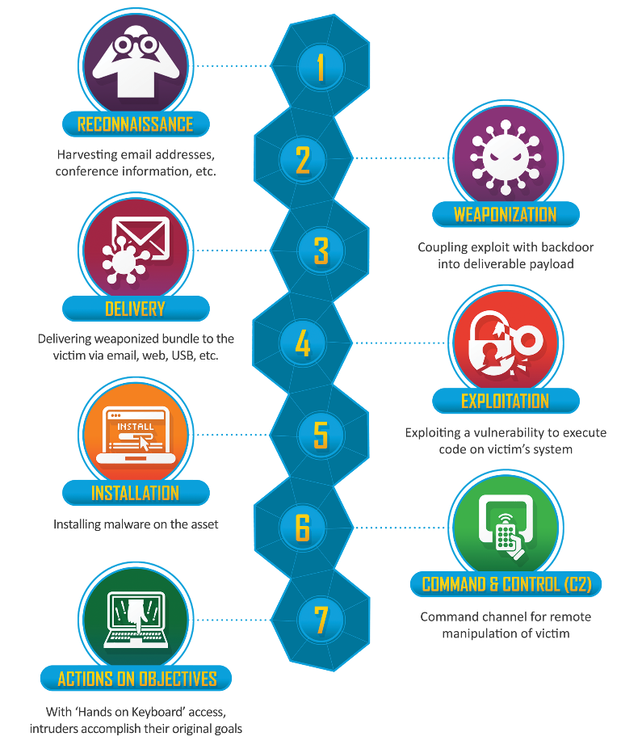

MITRE ATT&CK Framework
Using the same case study that was selected for 2.2.1, map out the entire attack for each event using the MITRE ATT&CK Framework. You can use the MITRE ATT&CK Navigator (https://mitre-attack.github.io/attack-navigator/) to help with the attack mapping. To start using the navigator, select ‘Create New Layer’ > ‘Enterprise’. Note that not all elements may apply to the attack, so do evaluate the case study thoroughly.

2.2.4 Presentation & Recommendation
Based on what was discussed in 2.2.1 and 2.2.2, identify possible security controls to mitigate or prevent a similar cybersecurity incident from occurring to your organisation. Compile all elements from 2.2.1 to 2.2.3 into a 10-minute presentation, with 5 minutes Q&A (each group to ask at least 1 question) by the rest of the group after the presentation is done.

